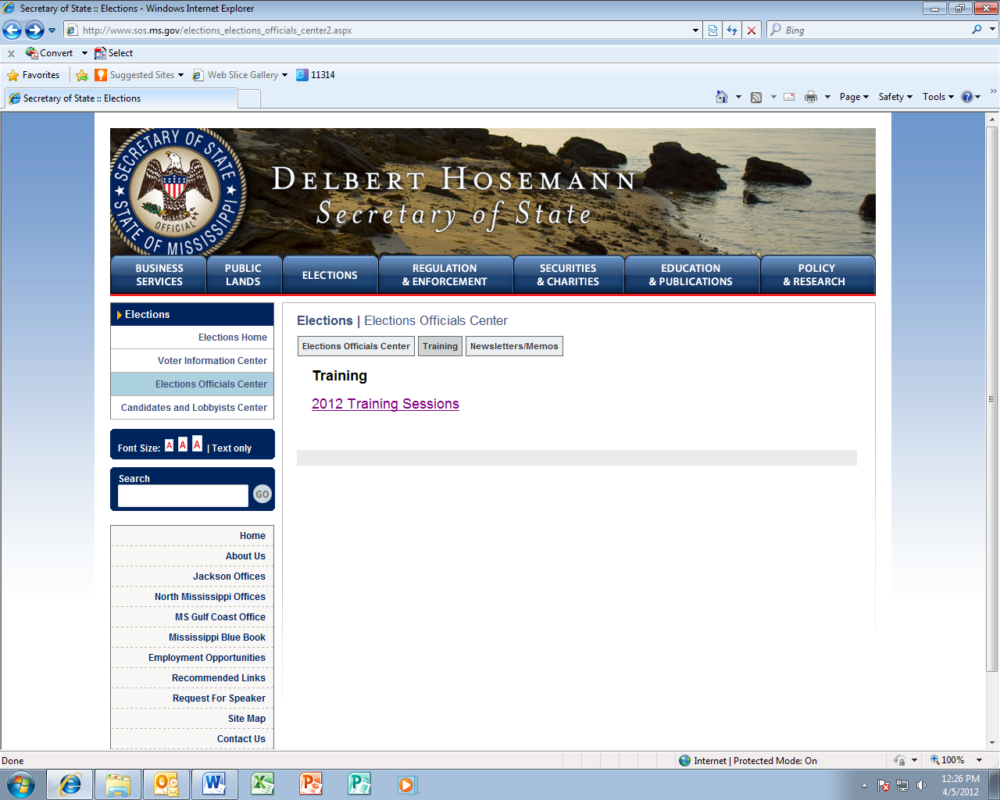

**Request for Update of Website**

**4.5.2012**

**Lindsay Leonard, Elections Training Coordinator**

Click ‘2012 Training Sessions” link

Click ‘Municipal Election Officials’ link

Please create a link for ‘Municipal Election Officials Certification’ similar to the screen provided here (example shown is for Party Executive Committee Members); do not add a ‘train the trainer ‘link as it does not apply to municipals.

*Please add a page for Municipal Certification similar to the screen provided here (example shown is for Party Executive Committee Members); please see sample text provided below:

**Elections |** 2012 Municipal Elections Certification Training

**Municipal Elections Certification Training**

**Dates and Locations:**  
(click on specific location for map)

**April 18, 2012 from 9:00 am – 5:00 pm at The Mississippi Secretary of State’s Office, 401 Mississippi Street – Jackson (please link to the following google map:** **http://www.bing.com/maps/default.aspx?encType=1&where1=401+Mississippi+St%2c+Jackson%2c+MS+39201&cp=32.302475~-90.182098&qpvt=401+Mississippi+Street%2c+Jackson%2c+MS&FORM=MIRE)**

\**Parking provided at the PERS Parking Garage next door to the SOS Mississippi Street Office, on the 4th Floor and above.*

***Map to PERS Parking Garage***

[**Municipal**](http://www.sos.ms.gov/links/elections/2012/ECT/MakeupMemoAndPreRegForm.pdf) **Elections Training Pre-Registration Form** (please link to pre-registration form attached in email)

*Note: Because of limited availability, we please ask that all persons planning to attend training, complete a pre-registration form above and send it in to our office as directed. Very Important - Make sure to mark the voting device portion of the registration as we will only offer voting device training for those who require it.*

Cont’d below…

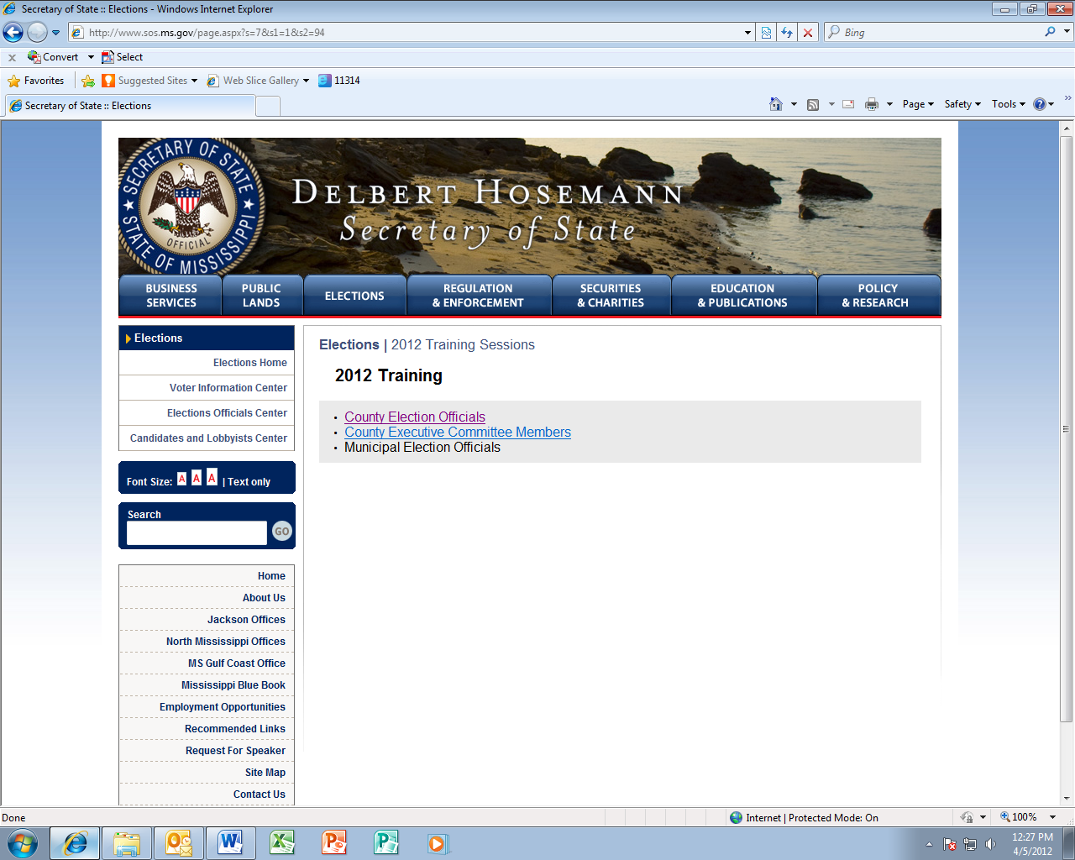

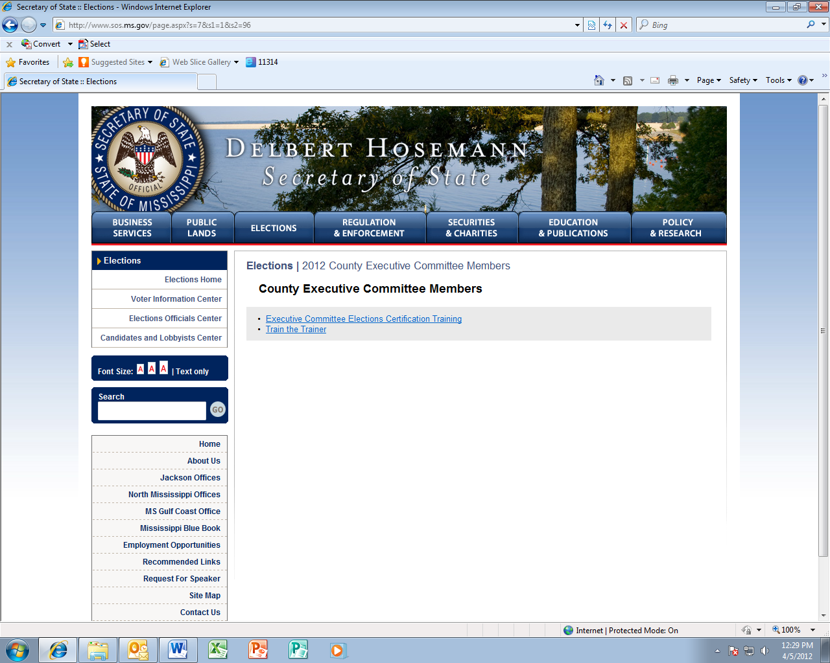

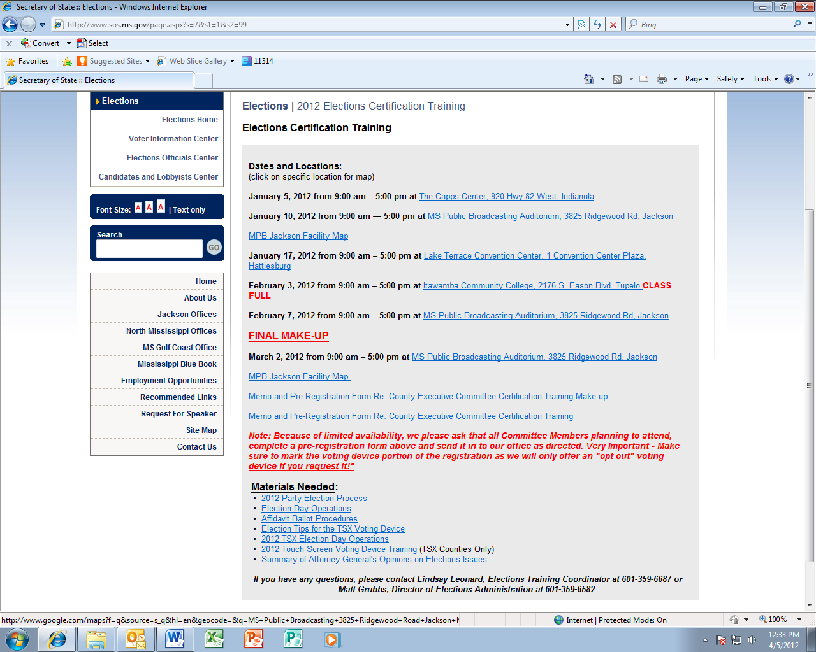



***Attendees will need to bring copies of the materials provided below:***

**Materials Needed:** (please link all below to the attachments provided in email)

* [Municipal](http://www.sos.ms.gov/links/elections/2012/ECT/1.%20Executive%20CommitteeProcess-party%20training.pptx) Elections Overview
* [Poll](http://www.sos.ms.gov/links/elections/2012/ECT/Executive%20Committee%20Training%20Election%20Day%20Operations.pptx) Manager Overview
* [Affidavit](http://www.sos.ms.gov/links/elections/2012/ECT/3.%20Executive%20Committee%20Trg%20Affidavit%20Ballot%20Procedures.pptx) Ballot Procedures
* Absentee Ballot Procedures
* Resolution Boards
* [Election Tips for the TSX Voting Device](http://www.sos.ms.gov/links/elections/2012/ECT/4b%20%20TSX%20Tips%202012(Exec).ppt)
* [2012 TSX Election Day Operations](http://www.sos.ms.gov/links/elections/2012/ECT/4a%20%202012%20TSX%20Election%20Day%20Operations.ppt)
* [2012 Touch Screen Voting Device Training](http://www.sos.ms.gov/links/elections/2012/ECT/2012%20Touch%20Screen%20Voting%20Device%20Training.ppt) (TSX Counties Only)

***If you have any questions or concerns, please contact Lindsay Leonard, Elections Training Coordinator at 601-359-6687 or Matt Grubbs, Director of Elections Administration / HAVA Administrator at 601-359-6582****.*